Automatically Generate Two-Dimensional Gating Hierarchy from Clustered Cytometry Data

# Author

Xingyu Yang, Peng Qiu

Xingyu Yang

Department of Biology, Georgia Institute of Technology, Atlanta, GA

Email: [xyang88@gatech.edu](mailto:xyang88@gatech.edu)

Peng Qiu

Department of Biomedical Engineering, Georgia Institute of Technology, Atlanta, GA

Email: [peng.qiu@bme.gatech.edu](mailto:peng.qiu@bme.gatech.edu)

# Abstract

Cytometry is an important technique widely used in medicine and biological research. Biologists traditionally analyze single-cell cytometry data by manual gating, which can be subjective and labor intensive. To address this issue, many automated and semi-automated methods have been developed. These advanced methods are designed to speed up and standardize the analysis of cytometry data, but their popularity is limited by non-intuitive visualizations and difficulties in interpretation. In this paper, we present a new method called Cluster-to-Gate (C2G) that can take clustering results as input, and automatically generate a nested two-dimensional gating hierarchy, which is a visualization representation that biologists are familiar with. This method can generate gating sequences for multiple target populations simultaneously and summarize them in one hierarchical tree that represents the gating hierarchy. We have tested this method on manually gated populations, populations defined by automated clustering methods (k-means and PhenoGraph), as well as populations defined by visualization-assisted methods (SPADE and tSNE). We have demonstrated that C2G is able to generate gating sequences that capture cell populations defined by the various clustering strategies, and robust to over-clustered and overlapping target populations.

# Introduction

Cytometry is a popular technique with wide applications in biology and medicine. It can measure the expressions of multiple protein biomarkers for a large number of cells, and provide data to reveal cellular heterogeneity and subpopulations [1, 2]. Traditionally, flow cytometry data is analyzed by manual gating, where gates are manually drawn on user-defined sequences of nested two-dimensional plots. Manual gating is a subjective and labor intensive process, especially when the number of protein biomarkers grows large [3].

Recently, new analysis algorithms [4-6] are developed to cluster flow cytometry data in high dimensional space. However, it is a nontrivial challenge to represent the high dimensional clustering results in a way that is easy to understand and interpret [7]. Motivated by this challenge, several visualization methods (e.g., tSNE, SPADE) are developed to project high dimensional data into two dimension, creating two-dimensional visualizations that can help biologists to interpret the data. Although these nonlinear visualizations provide rich information about the high-dimensional relationship in the data, they are still not intuitive to biologists who are accustomed to the two-dimensional nested gating representations. To interpret the high-dimensional analysis results intuitively, people developed tools like flowtype[7] and flowCL[8]. These methods pick up cutoffs and interpret clusters using two or more partitions per marker. However, such simple thresholding on each marker independently cannot properly interpret automated clustering results. Firstly, no automated method is perfect, for instance, they usually over-cluster the data or performs bad on unbalanced data. To make things worse, even with perfect automated method, the real cell population cannot always be interpreted simply by thresholding on each marker independently for reasons including imperfect compensation, marker co-expression or . Therefore, there is a gap and hence an opportunity to bridge between high-dimensional analysis results and traditional gating representations.

To bridge the gap between the advanced data analysis and traditional manual gating, we present a new method called Cluster-to-Gate (C2G) to generate nested 2D gating hierarchy of pre-defined populations of interest. Given a flow cytometry dataset and some clustering results that defines one or multiple target populations of interest, C2G is able to generate a gating hierarchy that captures the target populations, and present the hierarchy in nested two-dimensional gating sequences that resemble the conventional manual gating analysis. The gating hierarchy is constructed using a greedy approach to select marker pairs, and polygon-like gates based on overlaps between different target populations of interests and unlabeled cells. With this approach, biologists can obtain gating visualizations for cell populations generated by any clustering algorithms, which are more intuitive and easier to interpret. It will also benefit future algorithm developers to analyze the performance of their algorithms. We applied C2G to examine both simulated data and previously published mass cytometry data [9] to demonstrate its performance and robustness.

# Results

## Overview of this Method

### General Workflow

Inputs of C2G are single-cell data generated by flow cytometry or mass cytometry, and cell labels indicating which cells belong to the pre-defined populations of interest. Flow and mass cytometry data are typically stored in the FCS format [10] which contains intensity measurements of multiple protein markers across a large number of cells. Since the input cell labels only cover target populations of interest, which are not necessarily all the populations in the data, we first pre-cluster the unlabeled cells based on their overlap with target populations. Then, we use a greedy approach to generate a gating hierarchy iteratively. The iterative algorithm starts from the root node of the gating hierarchy, which contains all cells in the data. We automatically derive gates based on all possible marker pairs, and develop an entropy measure to evaluate their ability in separating the target populations and the pre-clustered unlabeled cells. Gates derived based on the best marker pair define cell subsets, which form children nodes of the root node and are subjected to further gating iterations. This process repeats until no marker pair in any node can further separate any target populations (Figure 1). Output of the algorithm is a tree representation of the gating hierarchy, and two-dimensional plots of the selected gates. To illustrate this method, we generated a simulated dataset in three dimension with five cell populations, and cell labels that cover two of the populations (Figure 2a). Given such inputs, C2G automatically generated a gating hierarchy to gate for the two target populations.

### Pre-Cluster the Unlabeled Cells

When we are only interested in a subset of the populations in the data, the input labels only cover the cells belonging to the populations of interest, and the remaining cells are considered as unlabeled. It is essential to pre-cluster the unlabeled cells, so that we can develop an effective measure to evaluate the overlap and separation among the target populations and the unlabeled cells. We pre-cluster the unlabeled cells based on their marker expression in relation to the target populations. Figure 2b shows an example with two target populations and three markers. For target population 1 and marker 1, we define two thresholds based on the 1th and 99th percentile of the marginal distribution of the marker’s expression in the target population. These two thresholds can be used to define one feature to characterize an unlabeled cell: is marker 1 expression of the unlabeled cell lower (-1), similar (0), or higher (-1) than target population 1. By examining all target populations and all protein markers in this example, an unlabeled cell is characterized by 6 features with values -1/0/1, showing whether its expressions of the three markers are low/similar/high with respect to the two target populations. Pre-clustering is performed by grouping unlabeled cells with the same values in all features into the same cluster. Since outliers in the data will form clusters with very small number of cells, we discard clusters whose sizes are smaller than a certain threshold (e.g., 5 cells). In the example shown in Figure 2, the unlabeled cells (gray in Figure 2a) are pre-clustered into 4 clusters shown in Figure 2c. Although the pre-clustering method may not be perfect (e.g., the bottom-left unlabeled population is divided into two clusters), it is sufficient for the purpose of measuring the separation between target population and unlabeled cells.

### Draw Best Gates for Each Marker Pair

Given a set of cells (represented by one node in the tree of gating hierarchy) and a marker pair (which define a biaxial plot on which gates can be drawn), we would like to automatically generate gates that are able to separate as many populations as possible, both the target populations and pre-clustered populations from unlabeled cells. In the two-dimensional space defined by the marker pair, we first compute the overlap between all pair of populations by drawing the convex hull of each population and counting the fraction of each population falling into convex hulls of other populations. For example, the overlap between populations $i$ and $j$ is defined as $max⁡(\frac{N_{ij}}{N_{i}},\frac{N_{ji}}{N_{j}})$, where $N_{i}$ and $N_{j}$ are the total cell counts of the two populations, $N_{ij}$ represents number of cells from populations $i$ that fall into the convex hull of populations $j$, and $N_{ji}$ represents number of cells from populations $j$ that fall into the convex hull of populations $i$. Figure 2d shows the biaxial plots of the 6 target and pre-clustered populations for all three possible marker pairs in the example dataset, and Figure 2e visualizes the computed overlaps between each pair of populations.

After obtaining the overlap measurement between each pair of populations, we cluster the populations using the Markov Cluster (MCL) Algorithm [11], results shown in Figure 2f. The MCL algorithm clusters the populations into groups with small overlap, and automatically determines the appropriate number of groups. For each group that contains one or more target populations, a gate is drawn based on union of the convex hulls of all populations in this group (Figure 2g). Groups containing only pre-clustered unlabeled populations are ignored. Therefore, for each marker pair, we derive one or a few gates, where each gate covers one or multiple target populations.

### Identify Best Marker Pair

After deriving gates for each possible marker pair, we evaluate the gates and determine the best marker pair, where the corresponding gates (1) have least overlap between target populations and (2) exclude as many pre-clustered unlabeled populations as possible. These two goals sometime conflict with each other. For example, in the top panel of Figure 2g, the two target populations are separated, but only 3 of the 4 unlabeled populations are excluded. In the bottom panel of Figure 2g, all 4 unlabeled populations are gated out, but the two target populations completely overlap.

To balance these two goals in determining the best marker pair, we developed an entropy metric. For each marker pair, we count the effective number of cells in each gate from each population. If one cell falls into the intersection of $k$ gates, it is counted as $1/k$ toward each of the $k$ gates. The collection of all unlabeled populations is considered as one population, and the complement of the union of all gates is considered as one gate. Therefore, we obtain a $\left(m+1\right)*(n+1)$ matrix of effective counts, where $m$ is the number of target populations and the “+1” is the unlabeled cells, $n$ is the number of gates and the “+1” represent the outside of the gates which is a gate itself. We normalize each row of the effective counts matrix by the row sum, and obtain a matrix of conditional probabilities $p_{ij}$, indicating the probabilities of cells from population $i$ falling into gate $j$. To evaluate a marker pair, or more precisely the gates drawn based on the marker pair, a weighted entropy metric is defined as follows:

$$H= -\sum_{1≤i≤m+1}{\left(p_{i}\sum_{1≤j≤n+1}{p_{ij}\log\left(p_{ij}\right)}\right)}$$

where $p_{i}$ is the percentage of population $i$ out of all cells. In the biaxial plot based on a marker pair, if all target populations are separated from each other and separated from the unlabeled populations, the weighted entropy will be 0. Overlap between target populations and unlabeled populations will increase the entropy, whereas overlap between multiple target populations is not penalized. For example, if one marker pair leads to a gate that includes two target populations that overlap, it is considered equally good as another marker pair that leads to two gates that perfectly separate the two target populations. Therefore, in the example shown in Figure 2g, the gating strategy in the bottom panel has the lowest entropy and is considered as the best gate and the best marker pair.

### Construct a Gating Hierarchy with a Greedy Approach

We use a greedy approach to construct a gating hierarchy for the target populations. Starting from the root node which contains all cells in the data, we derive gates on all possible marker pairs and compute the weighted entropy. We identify the best marker pair with the lowest weighted entropy, and select the corresponding gate(s) to move forward. The selected gates form new children nodes. The algorithm iterates to examine cells that belong to each new node, and identify the best marker pair and gate(s) to further separate the target populations and exclude the unlabeled populations (Figure 2h and 2i). The algorithm stops generating gates for a node when one of the following two conditions is satisfied: (1) the node contains only one population, or (2) for all marker pairs, the automatically generated gate is a trivial gate that includes all cells in the node. Overall, the iterations stop until no marker pair in any node can further separate any target populations. The output of C2G is a tree structure representing the gating hierarchy, and two-dimensional plots of the selected gates at each tree node (except the leaves), as shown in Figure 2j. Given the weighted entropy for selecting the best marker pair, this iterative algorithm tends to first exclude unlabeled populations, and then separate the target populations.

## Generate gating hierarchies of populations defined by various methods

To evaluate the performance of C2G, we applied it to generate gating hierarchies for target populations defined in various ways, including manual gating, automated clustering algorithms such as k-means [12, 13] and graph partitioning methods [14], as well as visualization-based methods such as tSNE and SPADE [4, 5]. To measure how well our gating hierarchy captures the target populations, we computed the F-scores [6]. In addition, we also compute normalized mutual information (NMI), which is widely used for measuring similarity of graph partitioning results [15]. In this section, we used a published CyTOF dataset on T cells [9] as a testbed, and focused on the 12 surface markers to evaluate the ability of C2G to generate gates for T cell subpopulations.

### 1. Target Populations Defined by Manual Gating

In the T cell CyTOF dataset [9], three manually gated populations were provided, namely CD4+ effector memory T cells, CD4+ Naïve T cell, and CD8+ Naïve T cells. We treated these three manually gated populations as target populations, and the remaining cells as unlabeled. When applied to this dataset, C2G was able to generate the gating hierarchy in Figure 3. As shown in Table 1, all three target populations were accurately gated, with F-scores 0.999, 0.998, and 0.999. The NMI metric was 0.995, also close to perfect. Moreover, the gating hierarchy generated by C2G used the same set of markers in similar order as the manual gating analysis that defined those target populations.

### 2. Target Populations Defined by Automated Methods

Many popular clustering algorithms for cytometry analysis used variations of k-means [12, 13], which motivated us to use clusters defined by k-means as target populations to examine the performance of C2G. We clustered the data using k-means with k=10, and assumed all 10 clusters are target populations. C2G generated the gating hierarchy shown in Figure 4a, with representative gates shown in Figure 4b. The complete set of gates associated to this gating hierarchy are shown in Figure S1. The gating hierarchy had an average F-score of 0.882 and NMI of 0.758 (Table S1), meaning that C2G is able to generate gates for k-means defined populations.

We also defined target populations using PhenoGraph, which is a nearest neighbor graph based algorithm [14]. We assumed all 12 PhenoGraph clusters are target populations, and applied C2G to derive gates for the target populations. The resulting gating hierarchy showed an average F-score of 0.628 and NMI of 0.654 (Figure S2a, S2b), which was unsatisfactory. This was because C2G obtained a gate that included populations 1 and 6, but did not generate further gates to separate them. Similarly, C2G gated populations 2, 3, 7 and 8 together (Table S2a). Upon further inspection, we found that C2G did not separate those target populations because they are heavily mixed with each other in two dimensional spaces defined by all marker pairs. Therefore, although those populations may be separated in high dimensional space, they are not separable by nested two dimensional gates. If we treat populations 1 and 6 as one target population, and 2, 3, 7 and 8 as another target population, the average F-score increases to 0.840 and NMI increases to 0.791 (Table S2b).

### 3. Target Populations Defined by Visualization-based Methods

SPADE and tSNE are methods that can visualize high dimensional cytometry data in a two-dimensional space, where gates can be drawn to define populations. C2G is helpful for assisting the interpretation of gates drawn from SPADE or tSNE, by generating a nested gating hierarchy of 2D gates which is a visualization that biologists are more accustomed to. We applied SPADE to the T cell data, and manually gated the SPADE tree to obtain 4 target populations. We then applied C2G to generate a gating hierarchy for the target populations (Figure 4), which achieved an average F-score of 0.953 and NMI of 0.911 (Table 2). We performed the same analysis using tSNE, and achieved similar performance (Figure S3a-b, Table S3).

## Challenges in automated gating hierarchy

Depending on the data and definition of target populations, automated generation of gating hierarchy may encounter several challenges, such as unlabeled cells, over-clustered populations, and overlapping populations. We examined performance of C2G with respected to these challenges.

### Unlabeled Cells

When the input labels only account for one or a few of the populations in the data, most of the cells are unlabeled. The unlabeled cells can create challenges in identifying a gating hierarchy for the labeled target populations, because the unlabeled cells contain a mixture of other cell populations, debris and outliers. To address this challenge, we pre-cluster the unlabeled cells according to their marker expression relative to the target populations. As a result, the unlabeled cells are divided into clusters that typically do not highly overlap with the target populations. Although this pre-processing step is likely to generate more clusters than the number of distinct populations in the unlabeled cells, it breaks down the unlabeled cells in a way that is relatively easy to separate from the target populations. In the first example above, the target populations were three T cell subtypes, whereas all other cell types and outliers were unlabeled. After pre-clustering the unlabeled cells, C2G was able to generate a gating hierarchy that accurately captured the target populations (Figure 3).

We further evaluated C2G with respect to the number of target populations by comparing three setting. We clustered the T cell CyTOF data using K-means with K equal to 10, and defined the target populations to be all, or three, or only one of the K-means defined populations. Then, we applied C2G to generate a gating hierarchy for the target populations. Within each setting, we computed an F-score for each target population. As shown in Figure 6, C2G consistently achieved high F-score in all three settings, showing the robustness with respect to the input cell labels.

### Over-Clustered Populations

In most applications, the exact number of distinct cell populations in the data is unknown. One popular strategy is to over-cluster the data to ensure all distinct populations are separated [4, 13, 16], and merge the clusters later. Therefore, we tested C2G against input labels that represent over-clustered populations. We performed K-means to cluster the data and varied K from 3 to 150, and assumed that all K-means clusters are target populations. For each k, we applied C2G to generate a gating hierarchy and computed the average F-score and NMI. As shown in Figure 7, the average F-score was consistently above 0.8 up to K=15, and remained above 0.7 even when the number of clusters was increased to 150. The decrease of F-score for increasing K was mainly because C2G stopped before attempting to separate certain target populations that cannot be separated in 2D plots, which suggested that some of the over-clustered populations should be merged, similar to the example above on target populations defined by PhenoGraph. This analysis shows that C2G is able to handle over-clustered target populations.

### Overlapping populations

Populations defined by high-dimensional clustering or visualization-based methods may not always be separable in a gating hierarchy of two-dimensional plots. For target populations that substantially overlap with each other due to over-clustering, C2G is not able to separate them. For target populations that slightly overlap due to measurement noise, we would like to be able to separate them, and implemented the following in our workflow. Before generating gates based on a marker pair, we first compute the local density of each cell of each population. When computing the overlap between populations, we ignore a small percentage of low density cells. Our default is 5%, and this percentage can be tuned by users based on the data quality and tolerable amount of overlap. When drawing a gate by the union of convex hulls of populations in a cluster derived by MCL, we generate several convex hulls by ignoring 0%, 1%, …, up to 20% of low density cells, and select the convex hull with the highest F-score as the best gate to move forward. To evaluate this approach, we artificially added outliers into the manually gated populations above, which induced overlaps among the target populations and unlabeled populations. The number of outlier cells added to each population was equivalent to a fixed percentage of its size. Applying C2G to the data with various percentages of added outliers up to 32%, the resulting gates always accurately captured the target populations with average F-score above 0.8 and NMI above 0.7 (Figure 8). Although the added outliers caused redundant gates that only excluded a small number of cells, the resulting gating hierarchies demonstrated a robust hierarchical structure (Figure S5a-f).

# Discussion

In this work, we provide a new method that can generate a gating hierarchy of nested two-dimensional gates from populations defined by either manual analysis, automated clustering, or visualization-based methods. It fills the gap between high-dimensional analysis algorithms for flow and mass cytometry and the conventional gating visualization that biologists are more accustomed to, and can help to promote the adoption of high-dimensional analysis algorithms. In addition, the hierarchical represent can also benefit algorithm developers, assisting them to visualize their clustering results for debugging and parameter tuning.

Another potential application of C2G is to identify gating hierarchy for completely unlabeled data. Upon using any general clustering methods (for example k-means or its variants), we can apply our method to obtain a gating hierarchy to explain the relationship among the clusters. Such a hierarchical explanation is typically not available in high-dimensional clustering algorithms, except for RchyOptimyx [7]. Advantage of this application is that it is flexible and easy to interpret, because the gating hierarchy reveals which markers are important in separating which subsets of populations.

Since the total number of possible gating hierarchies is extremely large with respect to number of markers, number of target populations, and maximum depth of the hierarchy, it is computationally infeasible to identify the optimal gating hierarchy by exhaustively enumerating all possible gating hierarchies. Our method uses a greedy approach to iteratively select marker pairs based on which gates are generated. Such a greedy approach may not lead to the optimal gating hierarchy with the highest accuracy, because the optimal gating hierarchy may not start off with the optimal marker pair for the first gate. However, we have demonstrated with multiple examples that C2G is able to generate gating hierarchies that capture target populations defined by multiple clustering approaches.

Performance of our method of course depends on the quality of the input, in terms of the separation among target populations and unlabeled cells. For cases where the target and unlabeled populations do not overlap or moderately overlap, C2G is able to successfully generate gating hierarchies to gate for the target populations. As to cases where the target and unlabeled populations substantially overlap, our method will fail to derive a gating hierarchy to separate them. However, this provides an indication of the quality of the clustering analysis that generated the target populations, which can serve as diagnosis and quality control for the clustering analysis.

# Acknowledgements

This work was supported by funding from the National Institutes of Health (R01CA163481) and the National Science Foundation (CCF1552784).

# Reference

1. Baumgarth, N. and M. Roederer, *A practical approach to multicolor flow cytometry for immunophenotyping.* Journal of immunological methods, 2000. **243**(1): p. 77-97.

2. Bendall, S.C., et al., *Single-cell mass cytometry of differential immune and drug responses across a human hematopoietic continuum.* Science, 2011. **332**(6030): p. 687-696.

3. Lugli, E., M. Roederer, and A. Cossarizza, *Data analysis in flow cytometry: the future just started.* Cytometry Part A, 2010. **77**(7): p. 705-713.

4. Qiu, P., et al., *Extracting a cellular hierarchy from high-dimensional cytometry data with SPADE.* Nature biotechnology, 2011. **29**(10): p. 886-891.

5. Amir, E.-a.D., et al., *viSNE enables visualization of high dimensional single-cell data and reveals phenotypic heterogeneity of leukemia.* Nature biotechnology, 2013. **31**(6): p. 545-552.

6. Aghaeepour, N., et al., *Critical assessment of automated flow cytometry data analysis techniques.* Nature methods, 2013. **10**(3): p. 228-238.

7. Aghaeepour, N., et al., *RchyOptimyx: cellular hierarchy optimization for flow cytometry.* Cytometry Part A, 2012. **81**(12): p. 1022-1030.

8. Courtot, M., et al., *flowCL: ontology-based cell population labelling in flow cytometry.* Bioinformatics, 2015. **31**(8): p. 1337-1339.

9. Krishnaswamy, S., et al., *Conditional density-based analysis of T cell signaling in single-cell data.* Science, 2014. **346**(6213): p. 1250689.

10. Spidlen, J., et al., *Data file standard for flow cytometry, version fcs 3.1.* Cytometry Part A, 2010. **77**(1): p. 97-100.

11. Van Dongen, S.M., *Graph clustering by flow simulation.* 2001.

12. Ge, Y. and S.C. Sealfon, *flowPeaks: a fast unsupervised clustering for flow cytometry data via K-means and density peak finding.* Bioinformatics, 2012. **28**(15): p. 2052-2058.

13. Aghaeepour, N., et al., *Rapid cell population identification in flow cytometry data.* Cytometry Part A, 2011. **79**(1): p. 6-13.

14. Levine, J.H., et al., *Data-Driven Phenotypic Dissection of AML Reveals Progenitor-like Cells that Correlate with Prognosis.* Cell, 2015. **162**(1): p. 184-197.

15. Danon, L., et al., *Comparing community structure identification.* Journal of Statistical Mechanics: Theory and Experiment, 2005. **2005**(09): p. P09008.

16. Naim, I., et al., *SWIFT—scalable clustering for automated identification of rare cell populations in large, high‐dimensional flow cytometry datasets, Part 1: Algorithm design.* Cytometry Part A, 2014. **85**(5): p. 408-421.

# Figure Legends

Figure 1: General workflow of C2G

Figure 2: Gating hierarchy for a simulated illustrative example.

(a) Simulated data. Target populations are colored as red and yellow. The two target populations cannot be directly separated in the 2D biaxial plot of any marker pair. (b) Pre-cluster the unlabeled cells. Each subplot shows how the unlabeled cells overlapped with one target population in one marker. (c) Pre-clustering result. Each pre-clustered unlabeled population is shown with a separate color. (d) Draw 2D biaxial scatter plot of each possible marker pair. (e) Compute overlap between all target and unlabeled populations. (f) Apply MCL algorithm to cluster the populations. Populations clustered together are in the same eclipse. (g) Automatically draw gates on each marker pair. The blue polygons show the gates based on the population clusters derived by MCL. The entropy on top of each plot quantifies the quality of the gates, in terms of their ability to separate target populations from unlabeled cells, and from each other. The lower entropy the better gating quality. The red rectangle shows the best marker pair. (h) Cells obtained after the first gate. (i) Derive further gates by repeating steps (c)->(g) to cells in the first gate. (j) The final output of our method. First two figures show the gating sequence, and the third figure is a tree structure that represents the gating hierarchy.

Figure 3: Generate gating hierarchy for manually gated target populations.

(a) Automatically generated gates in 2D biaxial plots. Cells shown in each subfigure belong to the gate indicated by the subfigure title. Each polygon represents a gate. Node 1 means a dummy gate that contains all the cells. (b) Tree structure representing the gating hierarchy. Each node corresponds to one gate.

Figure 4: Generate gating hierarchy for target populations defined by k-means where k=10.

(a) Automatically generated gates in 2D biaxial plots. (b) Tree structure of the gating hierarchy.

Figure 5: Generate gating hierarchy for target populations defined by SPADE analysis.

(a) SPADE tree of the T cell CyTOF data. Four target populations are manually gated based on the SPADE tree. These populations represent: B cells, CD8+CD4- T cells, CD8-CD4+ T cells and CD19-CD8-CD4-CD44+ cells. (b) Automatically generated gates in 2D biaxial plots. (c) Tree structure of the gating hierarchy. figure on the bottom is the corresponding gating hierarchy towards the 4 populations defined by SPADE3.

Figure 6: Comparison of cases where one, some or all populations are given as target populations.

Data is clustered by k-means where k=10. “Know one” means one of the 10 k-means clusters is the target population and the remaining are unlabeled. In each of the “Know three” setting, three consecutive populations are defined as target (1-2-3, 2-3-4, …, 9-10-1, 10-1-2). “Know all” means all k-means clusters are target populations.

Figure 7: Impact of over-clustering.

K-means was used to cluster the data with k varying from 3 to 150. For each k, assume all k-means clusters are target populations (“Know all”), and apply our method to generate gates. Y axis represents two scores, the mean F-score and the normalized mutual information.

Figure 8: Impact of overlap among populations.

Various amount of outlier cells were added to the manually gated target populations in the T cell CyTOF data, which induced overlap among the target and unlabeled populations. When our method is applied to data with various amount of overlap, the resulting gating hierarchy accurately captured the target populations.

# Figures

Figure 1a

Preprocessing

Compute Overlap between populations

MCL Clustering of Populations

Find Best Marker Pair

Repeat until no further separation

Visualize Results

Figure 2

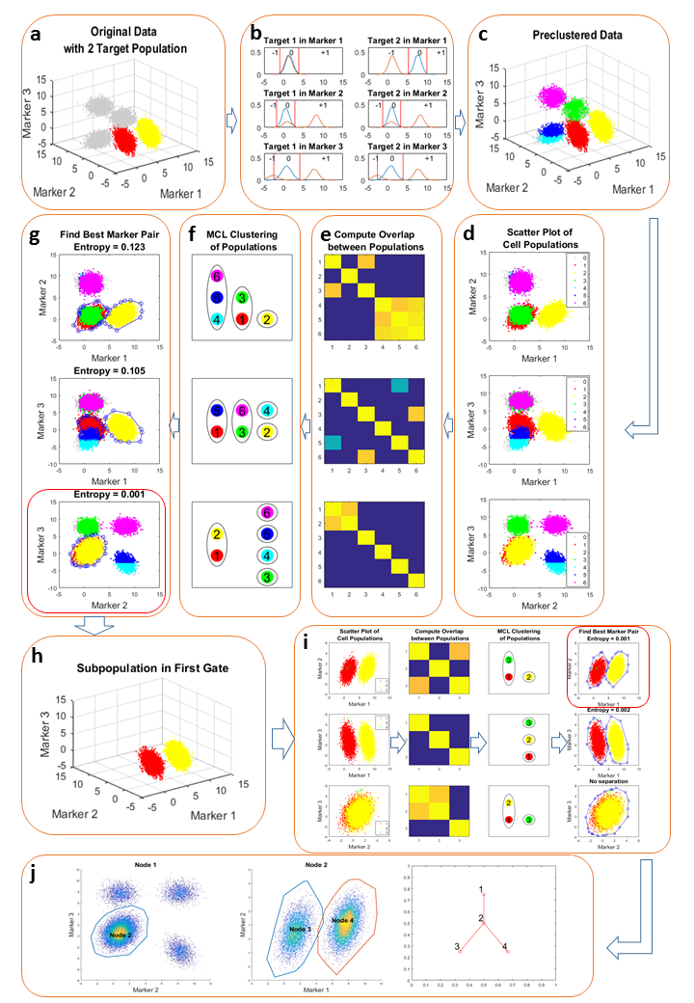

Figure 3a



Figure 3b



CD4+CD25-

CD44-CD8+

CD4-

CD44-

CD44+

TCRb+CD19-

Figure 4a



Figure 4b



Figure 5a



Figure 5b



Figure 5c



Figure 6 Know one vs. Know some vs. Know all



Figure 7 Addressing over-clustering



Figure 8 Performance on Different Noisy Level



# Tables

Table 1 Result on manual gated populations

|  |  |  |  |  |  |
| --- | --- | --- | --- | --- | --- |
| Cell Population | In Gate | True Positive | False Positive | False Negative | F-score |
| CD4+ Effmen | 7 | 214 | 1 | 0 | 0.998 |
| CD4+ naïve | 8 | 2290 | 8 | 0 | 0.998 |
| CD8+ naïve | 9 | 487 | 1 | 0 | 0.999 |

Table 2 Result on SPADE defined populations

|  |  |  |  |  |  |
| --- | --- | --- | --- | --- | --- |
| Target Population | In Gate | True Positive | False Positive | False Negative | F-score |
| 1 | 8 | 75 | 9 | 14 | 0.867 |
| 2 | 6 | 3556 | 98 | 0 | 0.986 |
| 3 | 5 | 1569 | 10 | 60 | 0.978 |
| 4 | 3 | 4318 | 0 | 172 | 0.98047 |

# Supplementary

Figure S1 This is the gating hierarchy generated from k means defined populations where k is 10. In this visualization, all gates including some redundant gates (for example Node 3 and 8) are represented.



Figure S2 a) This is the gating hierarchy generated from PhenoGraph defined populations with default parameters. b) The hierarchy tree. The number in the tree correspond to the node ID in a).

Figure S2a

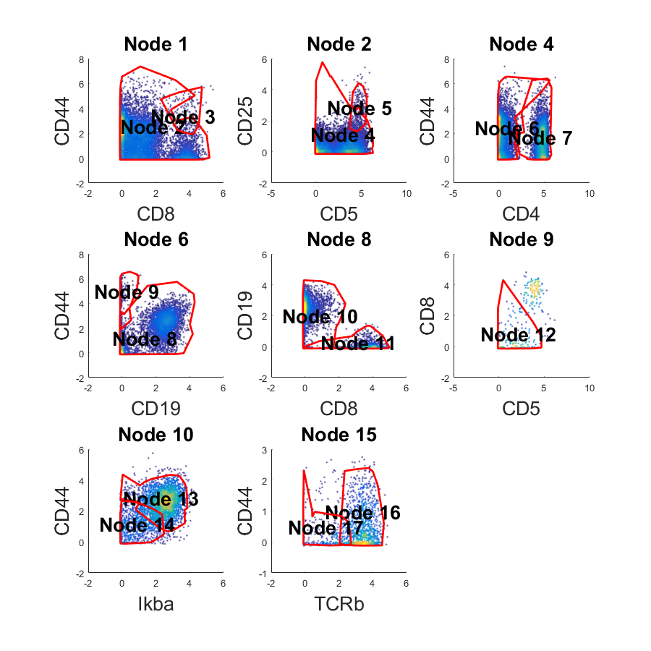

Figure S2b

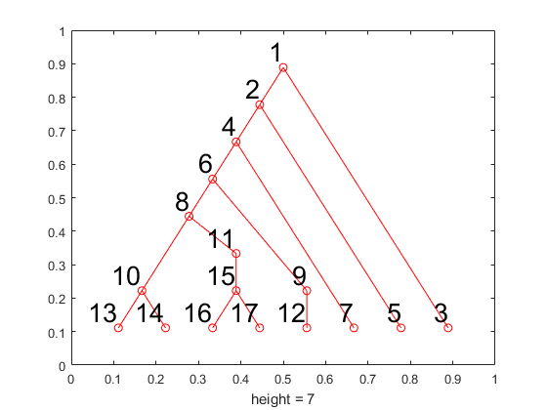

Figure S3 a) Manual define four populations based on tSNE visualization. b) Gating hierarchy generated by the populations defined in a). c) Hierarchy tree.

Figure S3a



Figure S3b



Figure S3c

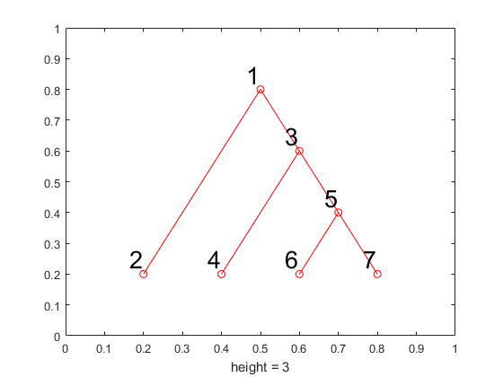

Figure S4 Here’s the SPADE visualization of the CyTOF data. Each figure is colored differently by expression of different marker. Blue means low expression cells and red is high expression cells.



Figure S5a-f

Figure S5a Add 1% outlier cells of each population





Figure S5b Add 2% outlier cells of each population





Figure S5c Add 4% outlier cells of each population





Figure S5d Add 8% outlier cells of each population



Figure S5d Add 16% outlier cells of each population





Figure S5e Add 32% outlier cells of each population

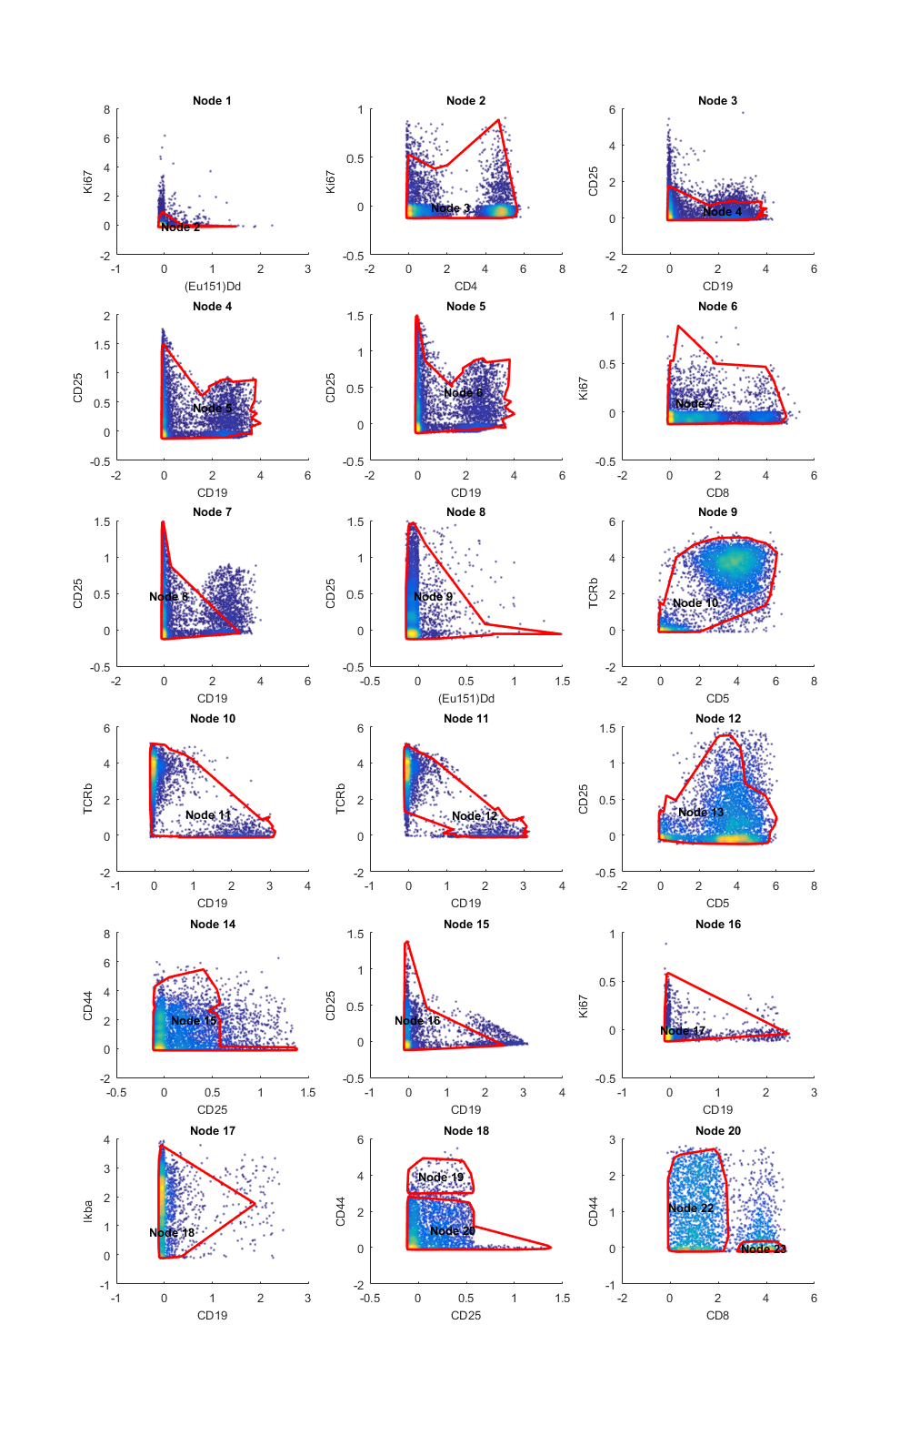

.

Table S1 Result on K-means defined populations

|  |  |  |  |  |  |
| --- | --- | --- | --- | --- | --- |
| Target Population | In Gate | True Positive | False Positive | False Negative | F-score |
| 1 | 13 | 1721 | 1003 | 103 | 0.756816 |
| 2 | 7 | 1321 | 2962 | 0 | 0.471449 |
| 3 | 7 | 1281 | 3002 | 0 | 0.46046 |
| 4 | 16 | 1042 | 60 | 121 | 0.920088 |
| 5 | 14 | 796 | 218 | 137 | 0.817668 |
| 6 | 13 | 743 | 1981 | 58 | 0.42156 |
| 7 | 7 | 798 | 3485 | 0 | 0.314111 |
| 8 | 7 | 748 | 3535 | 0 | 0.297356 |
| 9 | 17 | 217 | 85 | 69 | 0.738095 |
| 10 | 5 | 205 | 150 | 61 | 0.660225 |
| 11 | 3 | 160 | 42 | 32 | 0.812183 |
| 12 | 12 | 131 | 21 | 20 | 0.864686 |

Table S2a Phenograph

|  |  |  |  |  |  |
| --- | --- | --- | --- | --- | --- |
| Target Population | In Gate | True Positive | False Positive | False Negative | F-score |
| 1 | 13 | 1721 | 1003 | 103 | 0.756816 |
| 2 | 7 | 1321 | 2962 | 0 | 0.471449 |
| 3 | 7 | 1281 | 3002 | 0 | 0.46046 |
| 4 | 16 | 1042 | 60 | 121 | 0.920088 |
| 5 | 14 | 796 | 218 | 137 | 0.817668 |
| 6 | 13 | 743 | 1981 | 58 | 0.42156 |
| 7 | 7 | 798 | 3485 | 0 | 0.314111 |
| 8 | 7 | 748 | 3535 | 0 | 0.297356 |
| 9 | 17 | 217 | 85 | 69 | 0.738095 |
| 10 | 5 | 205 | 150 | 61 | 0.660225 |
| 11 | 3 | 160 | 42 | 32 | 0.812183 |
| 12 | 12 | 131 | 21 | 20 | 0.864686 |

Table S2b Phenograph Merged

|  |  |  |  |  |  |
| --- | --- | --- | --- | --- | --- |
| Target Population | In Gate | True Positive | False Positive | False Negative | F-score |
| 1 | 13 | 2464 | 260 | 161 | 0.921294 |
| 2 | 7 | 4148 | 135 | 0 | 0.983988 |
| 4 | 16 | 1042 | 60 | 121 | 0.920088 |
| 5 | 14 | 796 | 218 | 137 | 0.817668 |
| 9 | 17 | 217 | 85 | 69 | 0.738095 |
| 10 | 5 | 205 | 150 | 61 | 0.660225 |
| 11 | 3 | 160 | 42 | 32 | 0.812183 |
| 12 | 12 | 131 | 21 | 20 | 0.864686 |

Table S3 Results of tSNE defined clusters

|  |  |  |  |  |  |
| --- | --- | --- | --- | --- | --- |
| Target Population | In Gate | True Positive | False Positive | False Negative | F-score |
| 1 | 2 | 4415 | 32 | 0 | 0.996389 |
| 2 | 4 | 1565 | 29 | 41 | 0.978125 |
| 3 | 6 | 136 | 27 | 20 | 0.852665 |
| 4 | 7 | 3539 | 39 | 48 | 0.987858 |